**Movie-Square: Remaining Functionality**

(As of 7/15/17)

**Index Page**

1. Fix the gray extension (right side)

**Assigned to: Adam**

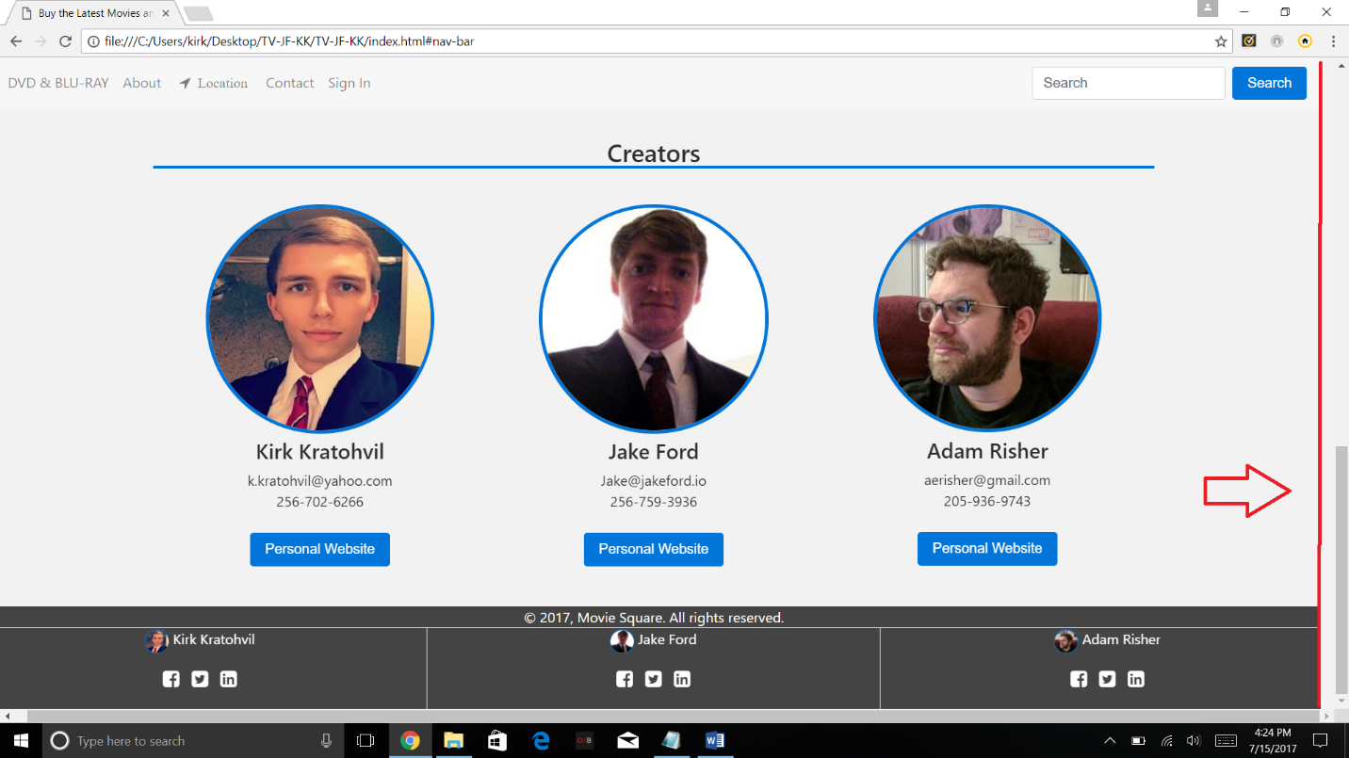

**Navigation Bar**

1. Add a logo to the navigation bar or above it

**Assigned to: Jake**

1. Give the search bar the ability to search for content on the index page and modals

**Assigned to: Adam**

1. Change the color of the navigation toggle button to white instead of being transparent.

**Assigned to: Adam**

1. Shift the navigation bar option to the right on desktop view

**Assigned to: Jake**

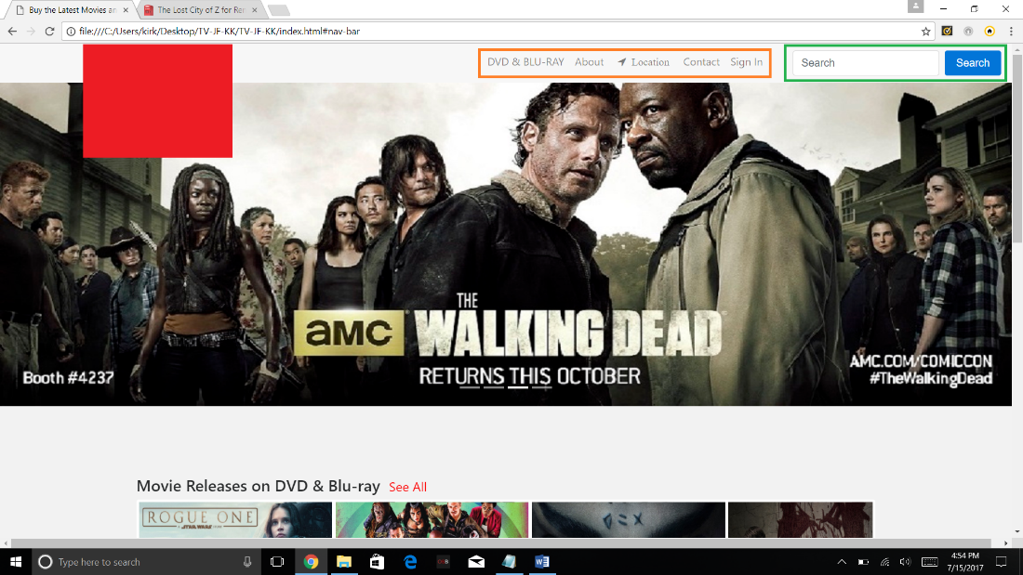

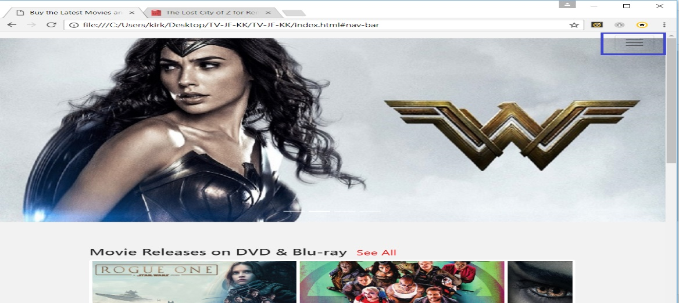

**Advertisement**

1. Add a nice advertisement above the navigation bar that advertises selling this website.

**Assigned to: Jake**

**Movie and Series Sliders**

1. Allow users to click on a movie on the movie slider via mobile. It currently doesn’t work.

**Assigned to: Kirk**

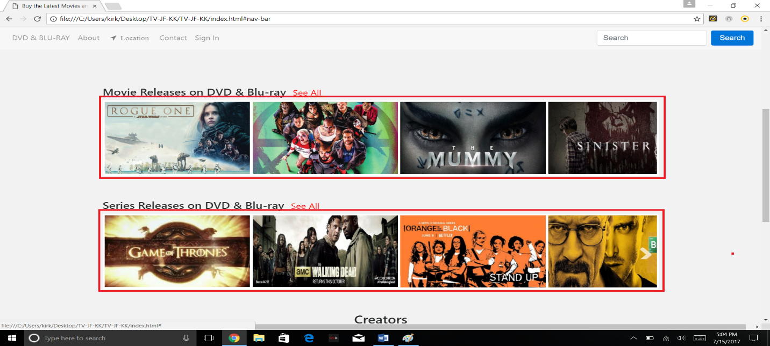

**Sign Up**

1. When a user fills in their sign up information, they should be prompted at the bottom to include at least one capital letter, one lowercase letter, one number, one special character, and that it should be at least 8 characters long. As the user fills out their password, checkmarks next to the requirements should light up green once requirements are met.

* If the email already exists, display, “That email address already exists”.
* If the password does not meet the above requirements, have a red border box appear around the requirements and display, “Make sure your password meets all of our requirements”

1. If the requirements above are met and the user hits “Create Account”, the user’s email and password should be immediately stored in the database, a welcome email should be sent to their email account, and they should be redirected to the index page now signed in.

**Assigned to: Adam**

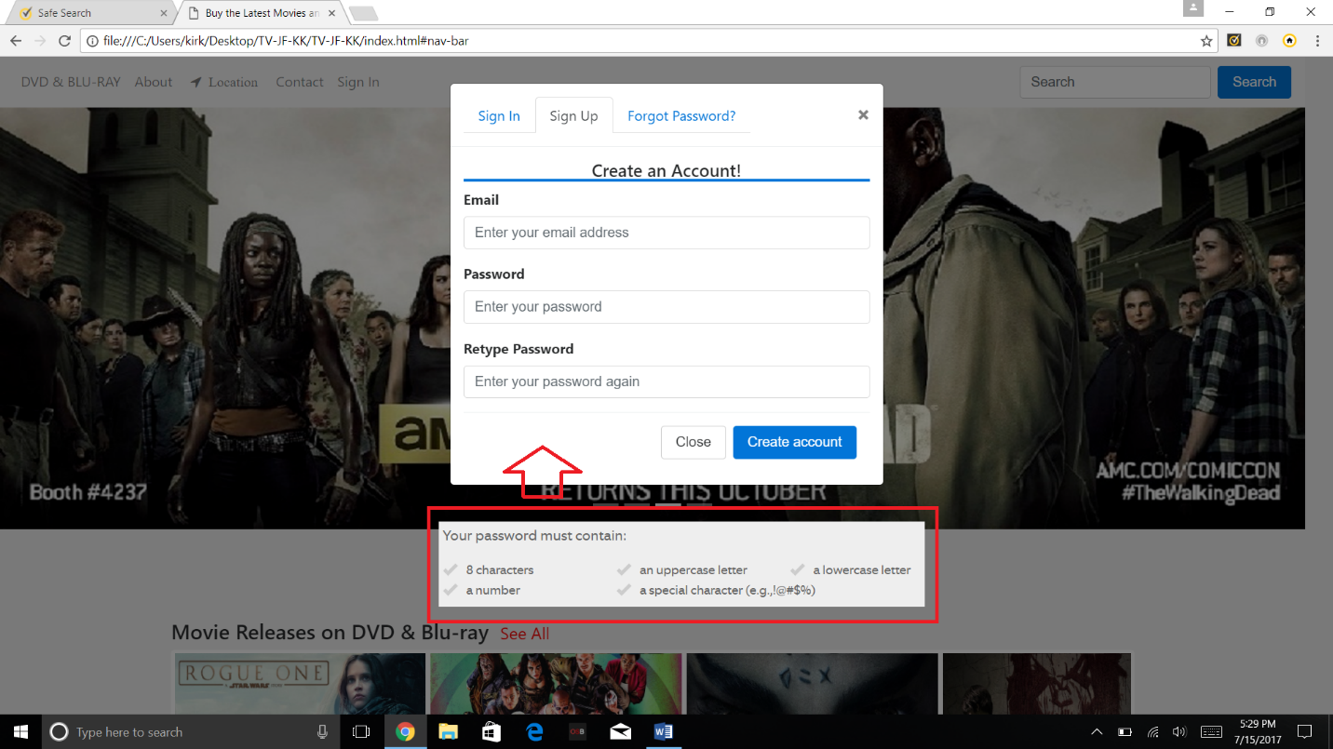

**Sign In**

1. Allow an existing user to sign into their account.

* If the sign in is successful, take them back to the index page with the “Sign In” navigation text now displaying a person icon. This icon will have three drop down options on click: “Purchases”, “Wishlist”, and “Sign Out”.
* If the sign in information in invalid, display the text, “Invalid user name or password. Please try again.”

**Assigned to: Adam**

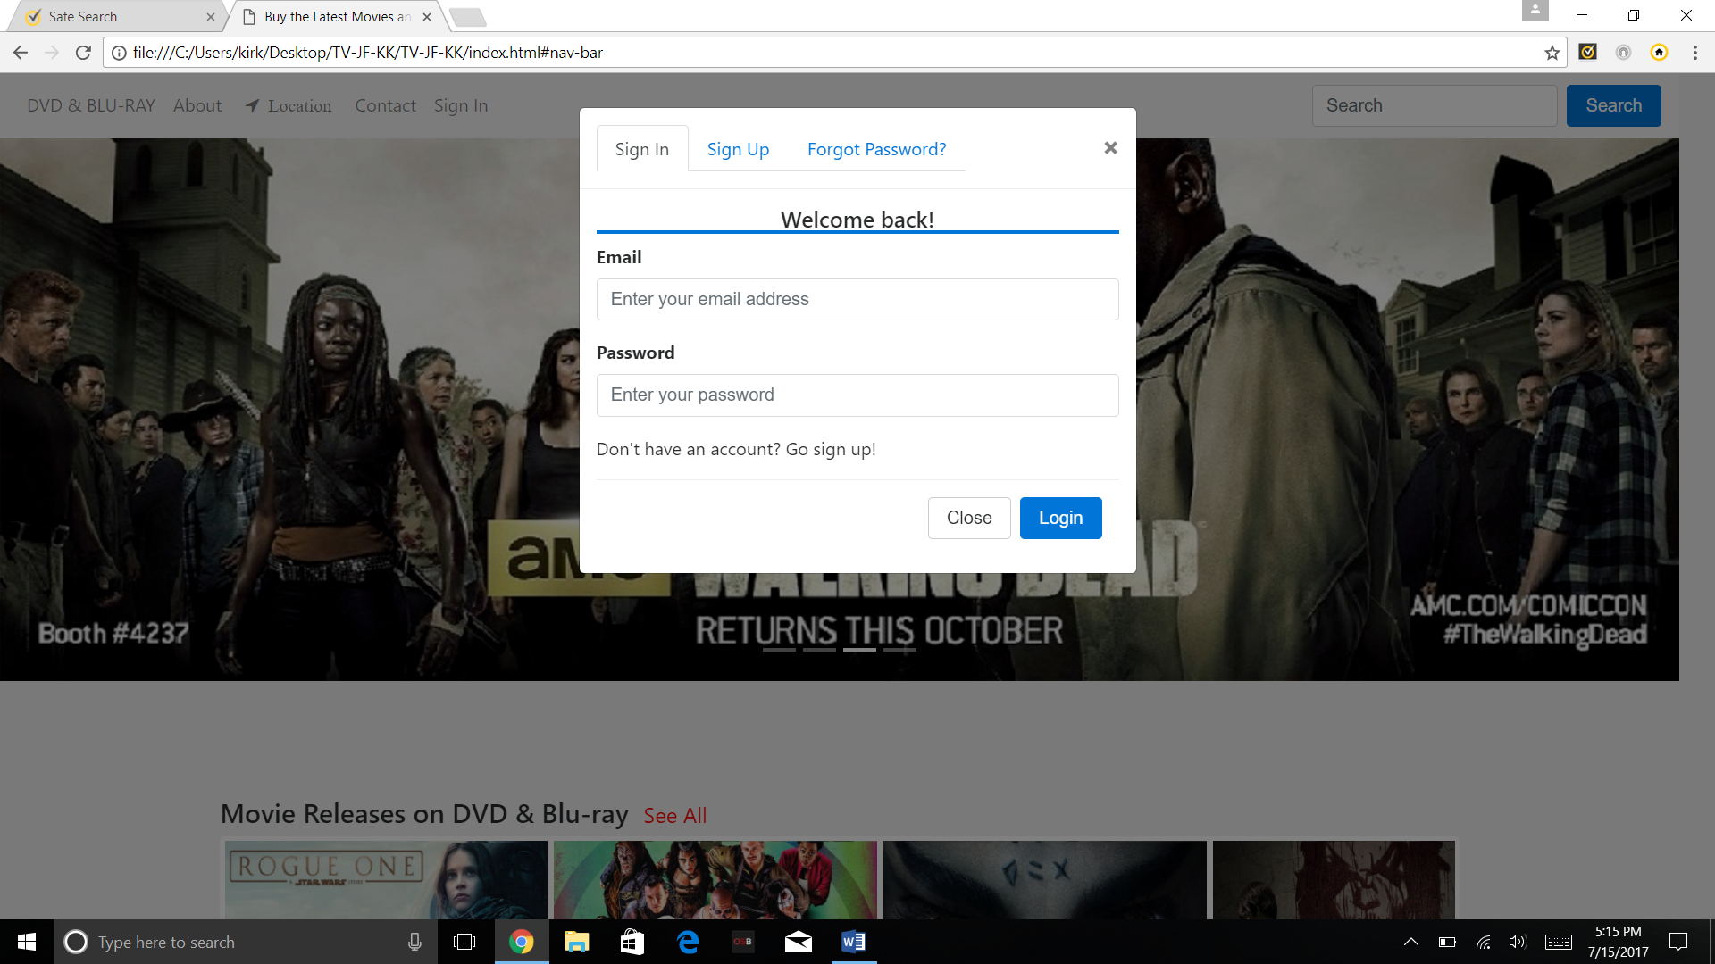

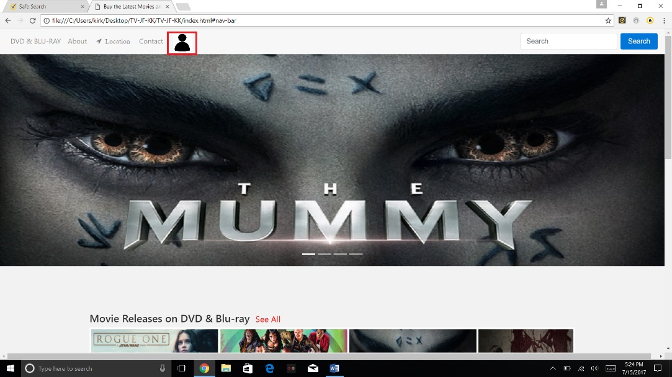

**Forgot Password**

1. Give the input field the functionality to search the database for existing email addresses.

* If it finds a match and the user hits submit, send a message to that user’s email account with their current password, and display text that reads, “We’ve sent your existing password to your email address!”
* If it doesn’t find a match, display the text, “That email address hasn’t been used to sign up for Movie Square. Please try again.

**Assigned to: Jake**

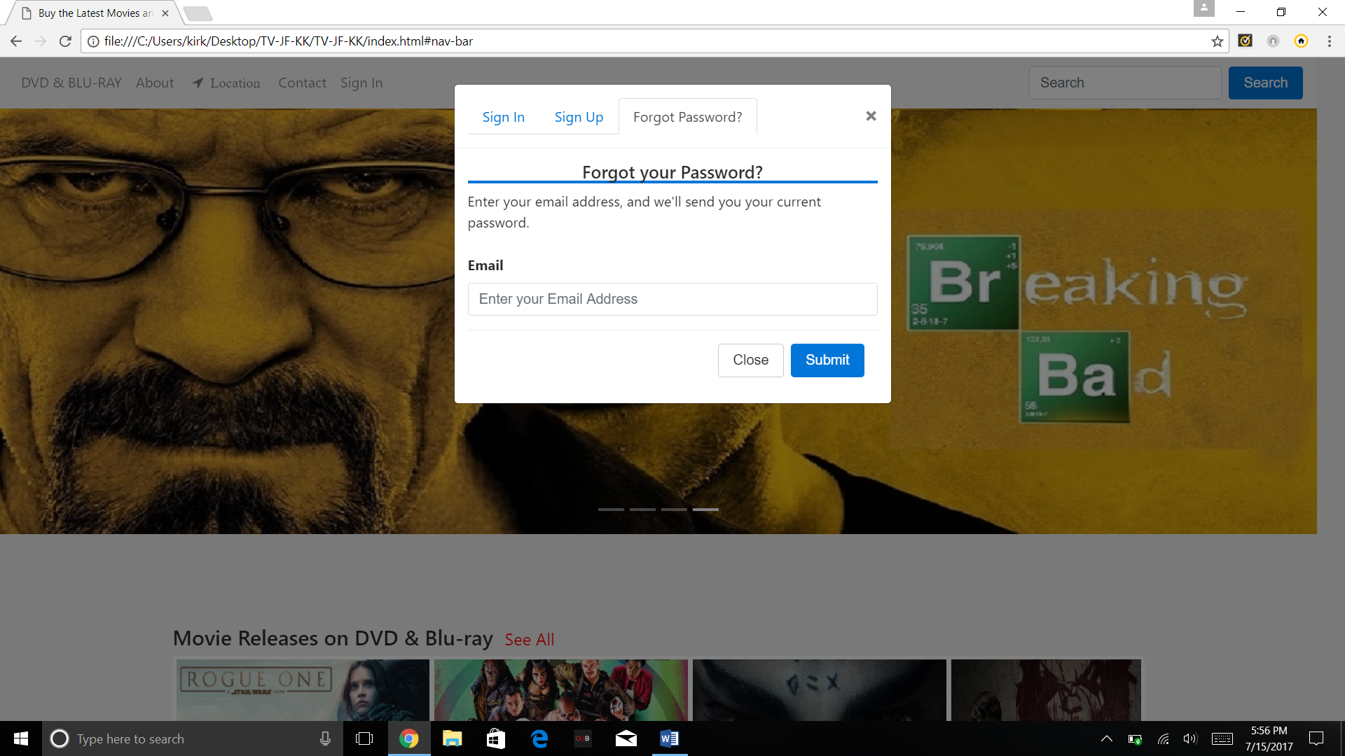

**Reviews**

1. On any movies and series modal, people who are signed in should be able to add their rating, some review text, and be able to post it to the review board.

**Assigned to: Kirk**

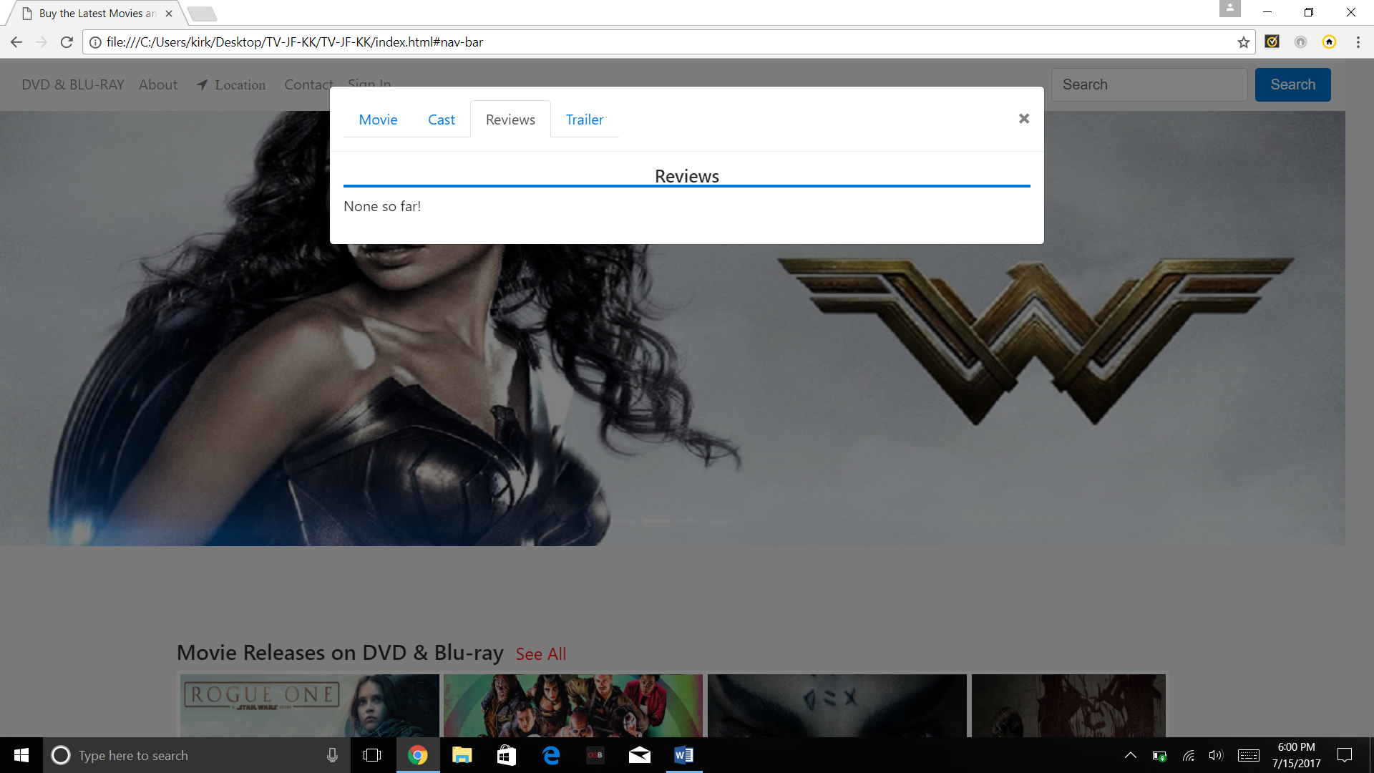

**Movies & Series Single Modals**

1. Add a rating system for movies and series (users only). Ratings should be able to stack with existing users who’ve already rated the same movie meaning the “mean” of all rating should be on display.

**Assigned to Jake**

1. Add a wish list feature for movies and series (users only). This will allow a user to add available movies and series to a wish list which will be stored on the “Wish List” modal which can be accessed once a user is signed in.

**Assigned to Jake**

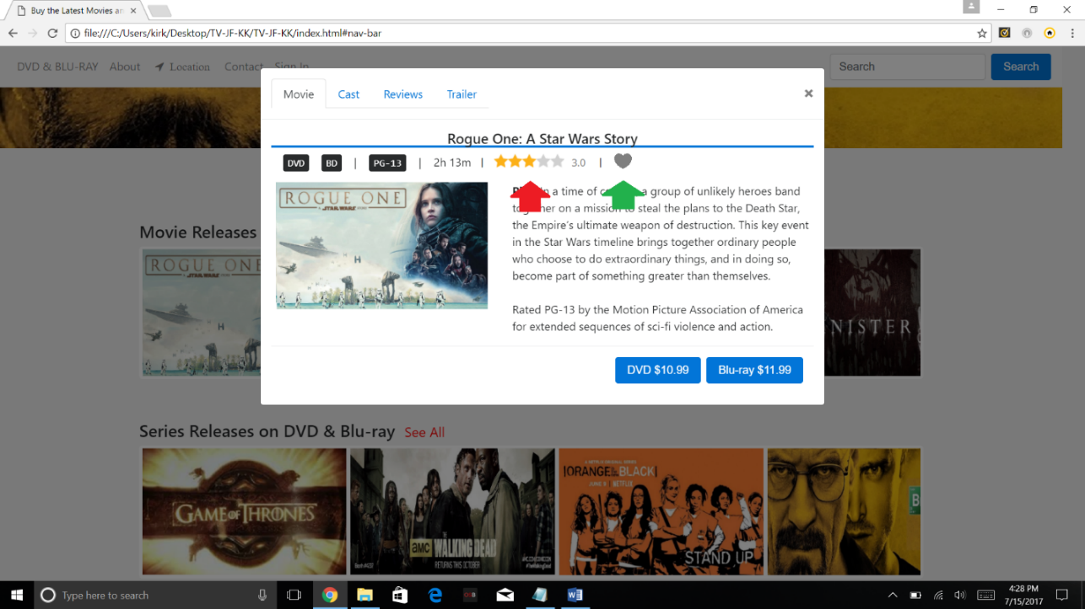

**Databases (Parameters)**

User Database: (ID, Email, Username, Password)

Series Database: (ID, Title, DVD Price, BR Price)

Movies Database: (ID, Title, DVD Price, BR Price)

Wishlist Database: (ID, Title, User, Email)

**Assigned to: Adam**

**Sign Out**

1. When a user clicks on the navigation person icon, they’ll have the option to sign out. This should completed end their session and take them back to the homepage where the “Sign In” navigation text is now showing

**Assigned to: Adam**

**Cart Checkout**

1. This is accessed by purchasing a DVD or BR movie or series in their respective modals. It will take the user to a modal displaying the movie, price, tax, and price plus tax. The next modal will prompt the user for their credit card information, address, and name. *We need to discuss the security options of this*. Once they fill in the correct information and checkout, a modal will appear saying, “Thank you for your purchase! A receipt will be sent to your email.” The user can then close the modal.

**Assigned to: Jake, Adam, Kirk**

**Purchases Modal**

1. Tab 1: Purchases in Cart

* This tab will display purchases you currently have in your cart where you can continue checking out.

1. Tab 2: Purchase History

* This tab will display your past purchase history.

**Assigned to: Jake, Adam, Kirk**

**Wishlist Modal**

1. Tab 1: Movies and Series Wishlist

* This tab displays a list of movies you’ve added to your wishlist.

1. Tab 2: Recommend a movie or series

* This tab allows users to input and submit movies or series they want to see in the shop. These will be stored in two separate databases

1. Tab 3: Movie and Series List

* This tab features a list of movies released in 2017. This will be done through Ajax, and calling JSON objects.

**Assigned to: Jake, Adam, Kirk**